**1. Software Development Life Cycle (SDLC)**

**Software development life cycle (SDLC) is a structured process that is used to design, develop, and test good-quality software.**

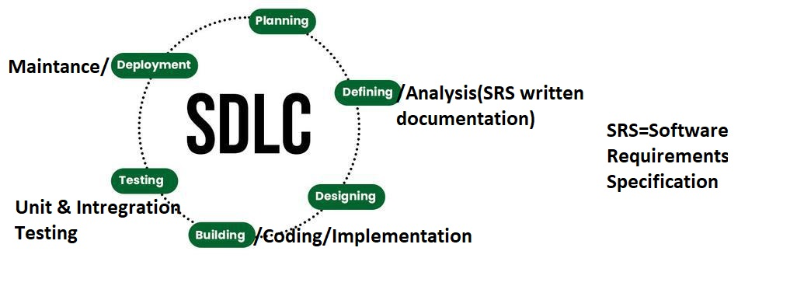

LINK- <https://www.geeksforgeeks.org/software-development-life-cycle-sdlc/>

**2. Software Engineering Basic Principles**

### Some of these principles include:

1. **Modularity**: Breaking down the software into smaller, independent, and reusable components or modules. This makes the software easier to understand, test, and maintain.
2. **Abstraction**: Hiding the implementation details of a module or component and exposing only the necessary information. This makes the software more flexible and easier to change.
3. **Encapsulation**: Wrapping the data and functions of a module or component into a single unit, and providing controlled access to that unit. This helps to protect the data and functions from unauthorized access and modification.
4. **DRY principle (Don’t Repeat Yourself):** Avoiding duplication of code and data in the software. This makes the software more maintainable and less error-prone.
5. **KISS principle (Keep It Simple, Stupid)**: Keeping the software design and implementation as simple as possible. This makes the software more understandable, testable, and maintainable.

LINK- <https://www.geeksforgeeks.org/basic-principles-of-good-software-engineering-approach/>

# 

# 3.Top 8 Software Development Life Cycle (SDLC) Models used in Industry

1. Waterfall Model (Classical & Iterative Waterfall)

2. V-shaped Model

3. Prototyping Model

4. Incremental Model

5. Evolutionary Model

6. RAD (Rapid Application Development) Model

7. Spiral Model

8. Agile Development Models

-------------------------------------------------------------------------------------------------------------------------------------

***1. Waterfall Model***

(Classical Waterfall Model)

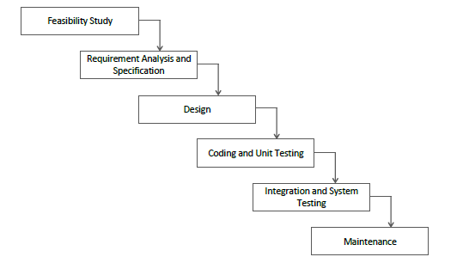

Link- <https://www.geektonight.com/classical-waterfall-model-software-engineering/>

(Iterative Waterfall Model) 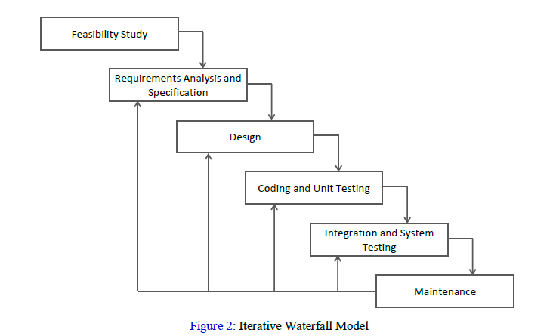

Link- <https://www.geektonight.com/iterative-waterfall-model-software-engineering/>

**-----🡪P.T.O**

***2. V-shaped Model***

**It is also known as the Verification & Validation Model**.

*Here Verification means step-by-step checking and Validation means check after completion of full project.*

The V-model in software development is a **parallel model** that allows for parallel **validation** and **verification** at each step. The V-model is a sequential execution model that has a corresponding **testing phase for each development phase**.

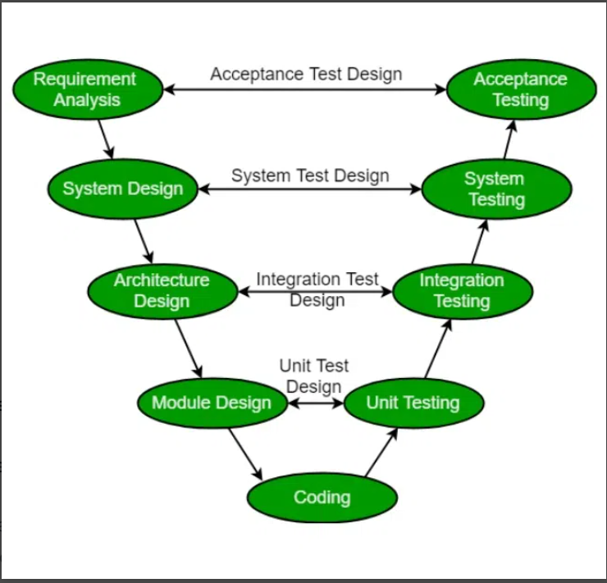

LINK- <https://www.geeksforgeeks.org/software-engineering-sdlc-v-model/>

**-----🡪P.T.O**

***3. Prototyping Model***

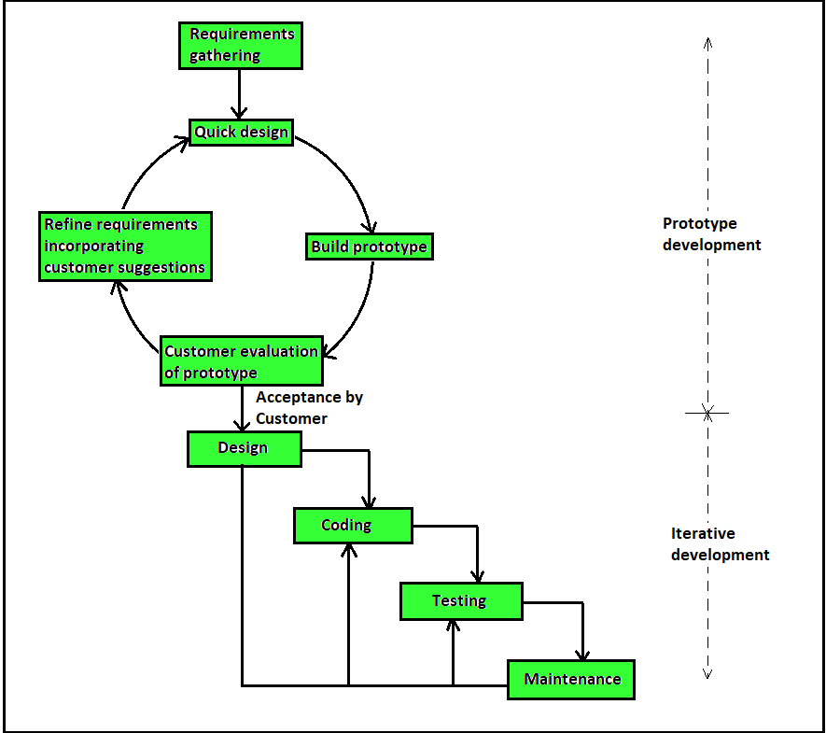

Link- <https://www.geeksforgeeks.org/software-engineering-phases-prototyping-model-set-2/>

**-----🡪P.T.O**

***4. Incremental Model***

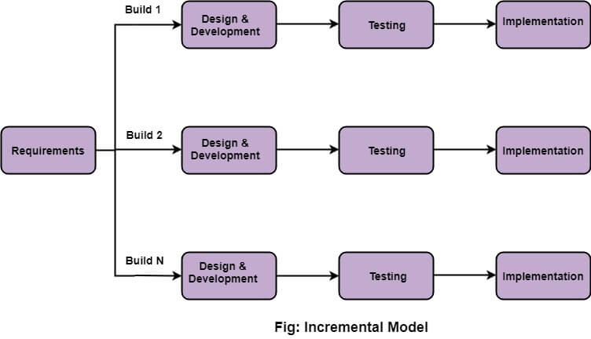

LINK- <https://www.javatpoint.com/software-engineering-incremental-model>

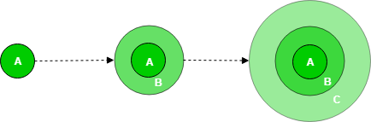

Link- <https://www.geeksforgeeks.org/software-engineering-incremental-process-model/>

***5. Evolutionary Model***

The evolutionary model is a combination of the [Iterative](https://www.geeksforgeeks.org/software-engineering-iterative-waterfall-model/)and [Incremental models](https://www.geeksforgeeks.org/software-engineering-incremental-process-model/) of the software development life cycle.

LINK- <https://www.geeksforgeeks.org/software-engineering-evolutionary-model/>

***6. RAD (Rapid Application Development) Model***

It is Based on ‘Time’ and It is ‘Parallel Computing’.

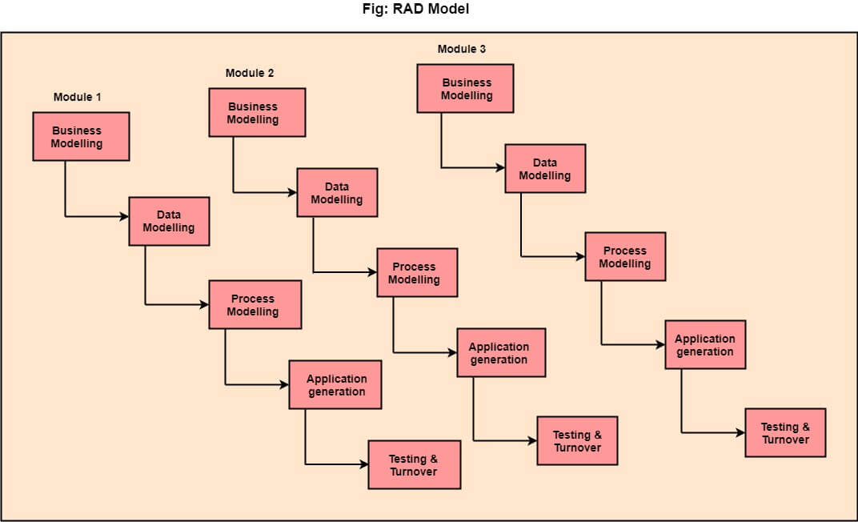

LINK- <https://www.javatpoint.com/software-engineering-rapid-application-development-model>

**-----🡪P.T.O**

***7. Spiral Model***

The Spiral Model is **a risk-driven model**, meaning that the focus is on managing risk through multiple iterations of the software development process.

The spiral model is called a **meta model**because it incorporates other software development life cycle (SDLC) models. These models include:

* Iterative waterfall model
* Prototyping model
* Evolutionary model

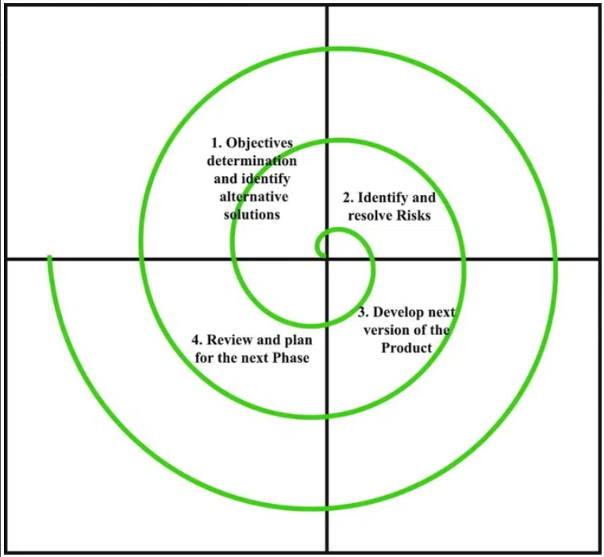

Link- <https://www.geeksforgeeks.org/software-engineering-spiral-model/>

***SEE THIS VIDEO PLAYLIST:***

***<https://www.youtube.com/watch?v=uJpQlyT_CK4&list=PLxCzCOWd7aiEed7SKZBnC6ypFDWYLRvB2>***

***8. Agile Development Models (Move Quickly)***

**The Agile Model** was primarily designed to help a project adapt quickly to change requests. So, the main aim of the Agile model is to facilitate **quick project completion**.

Agile methodology focuses on frequent iterations, quick market releases, and feedback incorporation for continuous improvement. It emphasizes face-to-face client communication, rapid changes, and minimal documentation for efficient product development.

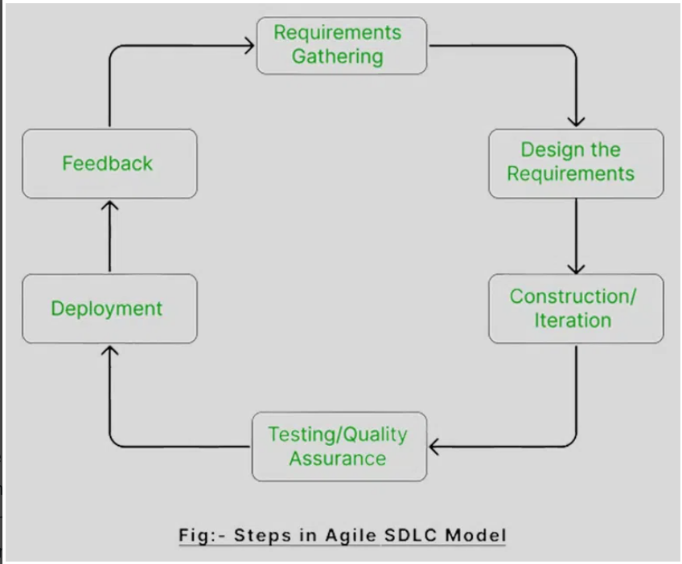

LINK- <https://www.geeksforgeeks.org/software-engineering-agile-development-models/>

some examples of Agile methodologies:

* Scrum
* Kanban
* Feature Driven Development (FDD)
* Dynamic Systems Development Method (DSDM)
* Large-scale scrum (LeSS)
* Scrumban
* eXtreme Programming (XP)
* Adaptive Software Development (ASD)
* Crystal
* Lean Software Development (LSD)

>>SCRUM (Limited Time):

>>**Scrum (the name is derived from an activity that occurs during a rugby match) is an agile software development method.**

>>Main Moto of SCRUM We have to put maxium effort with in less time.

>>It is Lightweight, iterative & incremental framework.

>>It is Non-continuous process.

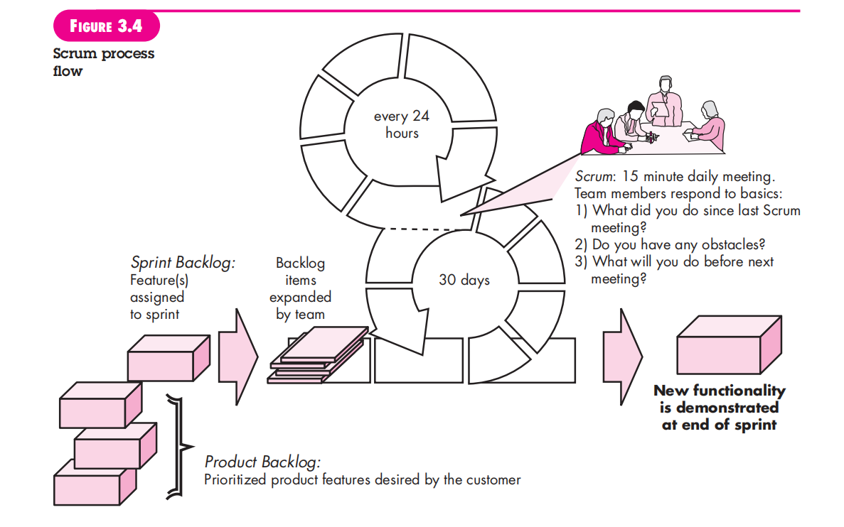

KEY-WORDS

**>>SPRINT: It means breakdown the development phases into stages or cycle.**

>>SCRUM-TEAM has scrum-master & product owner with const communication on daily basis

>>Backlogs (It means Pending Works): In Scrum, a backlog is a prioritized list of work that the development team needs to complete. This is typically known as the Product Backlog.

>>Daily Scrum: 10-15 minutes daily meeting here also employee work freedom & work adaption present

Means employee can give their idea to the Scrum-Master(Team Leader).

>>SCRUM-MASTER: A Scrum master is a leader who guides a team through a project using Scrum, an Agile framework for developing complex projects and Scrum master also work with the team-member/employee.

>>Product Owner: As a member of the Scrum Team, the Product Owner provides clarity to the team about a product's vision and goal.

**>>Advantages:**

Freedom & Adaption

High-Quality, low-risk product

Reduce the development time upto 40%

Scrum-Customer Satisfied is very important

**>>Disadvantages:**

More Efficient for Small Size Team

*No Changes on Sprint means onces work is assigned to the team member later on we can not change the assigned work*

>>Kanban:

>>Kanban or Kanbam is a Japanese word which translate to signboard is Visual System that is used for managing work as it goes through the process.

>>The Main Moto of Kanban can help determine the bottlenecks, fix them in cost-effective manner

>>It is a Continuous process.

LINK- <https://www.spiceworks.com/tech/devops/articles/what-is-agile-software-development/>

LINK OF YOUTUBE VIDEO: <https://www.youtube.com/watch?v=WjwEh15M5Rw&list=PPSV>

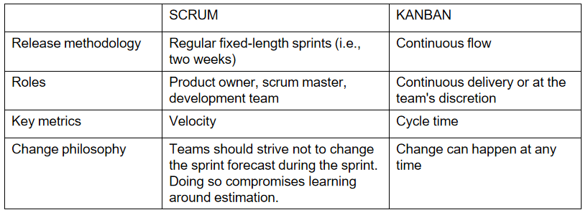

Difference Link- <https://www.youtube.com/watch?v=rIaz-l1Kf8w&list=PPSV>

**DEVOPS:**

**DevOps is a concept/process that bridges development team and operations team/departments in software development, ensuring collaboration and cost reduction. Small companies may combine these functions, but larger corporations separate them for efficiency.**

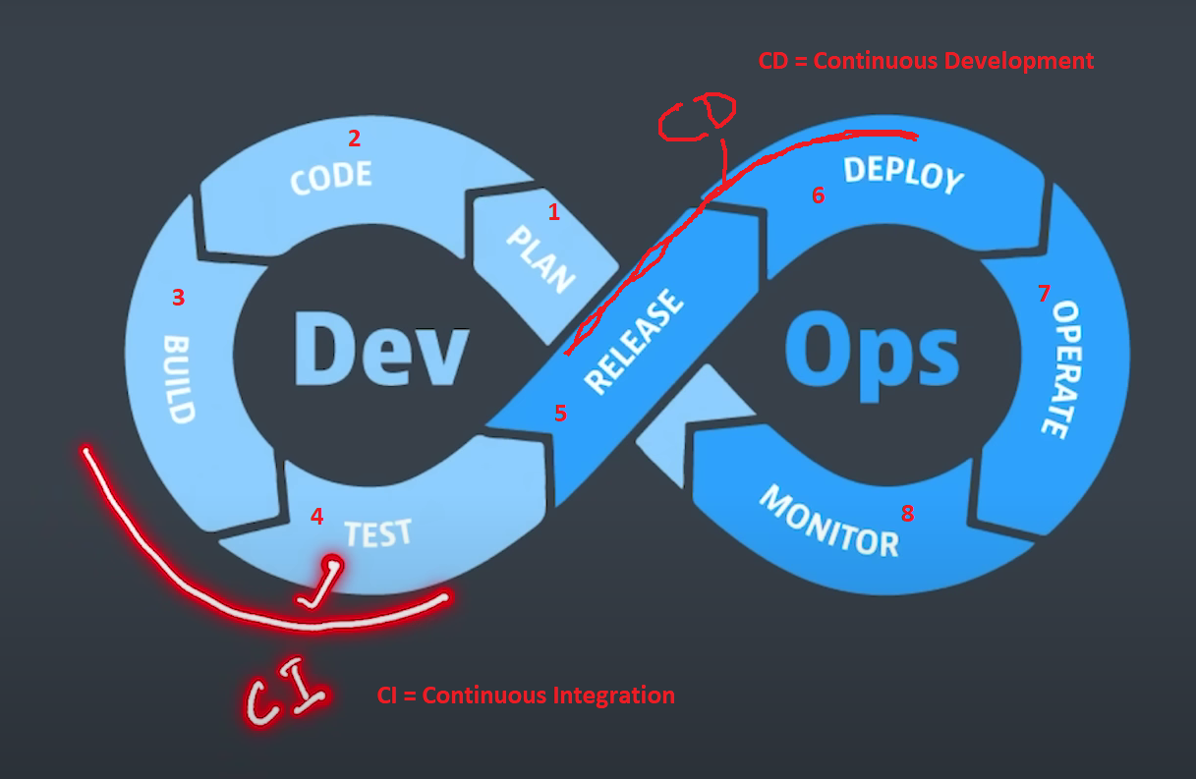

**LINK-** <https://www.youtube.com/watch?v=h7LDnVsNRVI>